Scaling LLMs with NVIDIA Triton and NVIDIA TensorRT-LLM Using Kubernetes
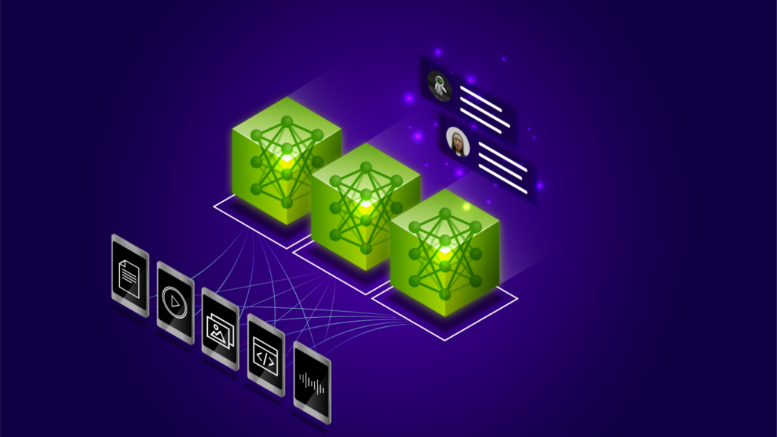
Oct 22, 2024
By Maggie Zhang, J Wyman, Indrajit Maloji Bhosale and Wenhan Tan
+12
Like
Discuss (0)
AI-Generated Summary
As of March 18, 2025, NVIDIA Triton Inference Server is now part of the NVIDIA Dynamo Platform and has been renamed to NVIDIA Dynamo Triton, accordingly.
Large language models (LLMs) have been widely used for chatbots, content generation, summarization, classification, translation, and more. State-of-the-art LLMs and foundation models, such as Llama, Gemma, GPT, and Nemotron, have demonstrated human-like understanding and generative abilities. Thanks to these models, AI developers do not need to go through the expensive and time consuming training process from scratch.
Techniques such as retrieval-augmented generation (RAG), prompt engineering, and fine-tuning can be applied to customize foundation models and achieve higher accuracy for specific tasks in much shorter time. The customized models can be deployed in production quickly and serve inference requests for a wide range of use cases.
This post provides step-by-step instructions on how to optimize LLMs using NVIDIA TensorRT-LLM, deploy the optimized models with NVIDIA Triton Inference Server, and autoscale LLM deployment in a Kubernetes environment.
NVIDIA TensorRT-LLM is an easy-to-use Python API that defines and optimizes LLMs. NVIDIA Triton Inference Server is an open-source inference serving software that supports multiple frameworks and hardware platforms. TensorRT-LLM provides multiple optimizations such as kernel fusion, quantization, in-flight batch, and paged attention, so that inference using the optimized models can be performed efficiently on NVIDIA GPUs.
Triton Inference Server supports multiple deep learning and machine learning frameworks, including NVIDIA TensorRT, TensorFlow, PyTorch, and ONNX. It supports multiple query types, including real time, batched, ensembles, or streaming. It can run across cloud, data center, edge and embedded devices on NVIDIA GPUs, x86 and ARM CPUs. As a developer, you can first build TensorRT engines that contain the model optimizations, then deploy the optimized models with Triton in production.
You can scale up the deployment of the optimized LLMs from a single GPU to multiple GPUs with Kubernetes, to handle thousands of real-time inference requests with low latency and high accuracy, and scale down the number of GPUs when the volume of inference requests decreases. This is especially useful for enterprises, such as online shopping and call centers, when handling different volumes of inference requests during both peak and non-peak hours with flexibility, while benefiting from the reduced total cost compared to purchasing the maximum number of hardware resources to handle the peak workloads.
Triton metrics are scraped by Prometheus and sent to Horizontal Pod Autoscaler (HPA) to make decisions on scaling up or down the number of deployment and GPUs based on the amount of the inference requests. To see the code and steps for this optimization and deployment, visit triton-inference-server / tutorials on GitHub.

Hardware and software requirements
For optimizing and deploying your models, you need to have NVIDIA GPUs that support TensorRT-LLM and Triton Inference Server. It is recommended to use the new generations of NVIDIA GPUs. You can find the list of supported GPUs in the hardware section of the support matrix for TensorRT-LLM. You can also deploy your models on public cloud compute instances with the appropriate GPU resources such as AWS EKS, Azure AKS, GCP GKE, or OCI OKE.
Kubernetes can be used to scale your deployment automatically to handle large-scale real-time inference requests with low latency. To enable Kubernetes to discover which nodes have GPUs and make them available to containers running on those nodes, install the Kubernetes node feature discovery service, NVIDIA device plugin for Kubernetes, GPU Feature Discovery service, and NVIDIA DCGM Exporter. You also need to install Prometheus to collect metrics for autoscaling. See detailed installation steps.

Optimize LLMs with TensorRT-LLM
TensorRT-LLM supports a variety of state-of-the-art models. You can download the model checkpoints from Hugging Face, then use TensorRT-LLM to build engines that contain the model optimizations. To download the LLMs, you will need an access token. You can then create a Kubenetes secret with the access token, which will be used in a later step of Kubernetes Deployment to download the models.
$ kubectl create secret generic hf-model-pull '--from-literal=password=<HF_access_token>'
To understand more about how TensorRT-LLM works, explore examples of how to build the engines of the popular models with optimizations to get better performance, for example, adding gpt_attention_plugin, paged_kv_cache, gemm_plugin, quantization.
To generate TensorRT engine files, you can use the Docker container image of Triton Inference Server with TensorRT-LLM provided on NVIDIA GPU Cloud (NGC). To pull the container image from NGC, you need to generate an API key on NGC that enables you access to the NGC containers. Next, log in to NGC using the API key to pull the container image.
After pulling the NGC image of Triton with TensorRT-LLM—for example, the base image nvcr.io/nvidia/tritonserver:24.08-trtllm-python-py3—generate TensorRT-LLM engine files referencing the Model Preparation Steps. Based on the model size and GPU memory size, you can configure TP tensor parallelism (TP) and pipeline parallelism (PP). Note that you need a minimum number of GPUs, TP*PP, for generating the engine files.
Create a custom Triton-TensorRT-LLM image following the Custom Container Image steps and scripts. After building the custom image, you can push it to a repository that your cluster can access. To pull this customized image from a private registry during deployment, you need to create a Kubernetes docker-registry secret with the API key and let Kubernetes use the secret to pull the image from the private registry.
During deployment, the generated TensorRT engine and plan files are stored in the host node and remapped to all the Kubernetes Pods on the same node. This eliminates the need to generate the same files if more Pods are scaled up later.

Autoscale deployment of LLMs with Kubernetes
After optimizing your LLMs with TensorRT-LLM, you can deploy the models using Triton and autoscale the deployment with Kubernetes. Three main steps are required to deploy LLMs for AI inference:
- Create a Kubernetes Deployment for Triton servers
- Create a Kubernetes Service to expose the Triton servers as a network service
- Autoscale the Deployment using Horizontal Pod Autoscaler (HPA) based on Triton metrics scraped by Prometheus

Helm chart for LLM deployment
You can use a Helm chart for deployment, as it is easy to modify and deploy across different environments. To find the Helm chart, see Autoscaling and Load Balancing Generative AI with Triton Server and TensorRT-LLM. Inside the chart directory, Helm expects the files as below:
chart.yaml holds all the information about the chart you are packaging; for example, version number and name.
values.yaml defines all the values you want to inject into your templates directory, including the supported GPUs, LLMs, the container image of Triton, image pull secrets, and so on. You can create a custom values file that is specific to your model, custom image, and GPU type to overwrite values.yaml. The following example is a gpt2_values.yaml for deploying a GPT-2 model on an NVIDIA A10G GPU.
gpu:
- NVIDIA-A10G

model:
name: gpt2
tensorrtLlm:
parallelism:
tensor: 1

triton:
image:
pullSecrets:
-name: ngc-container-pull
name: <your custom image>
If you have a larger model that does not fit on a single GPU, you can configure TP based on the model and GPU size. For example, you can set model.tensorrtLlm.parallelism.tensor to 2 for a model that needs two GPUs, and each Kubernetes Pod has two GPUs in Deployment.

Create a Kubernetes Deployment
A Kubernetes Deployment provides declarative updates for Kubernetes Pods and ReplicaSets. The deployment.yaml creates a set of replicated Pods for Triton servers. You can specify how many Pods to start your deployment with, indicated by the .spec.replicas field.
The .spec.containers field tells each Kubernetes Pod to have a Triton server container running on a GPU. Port numbers 8000 and 8001 are specified for Triton servers to receive inference requests from clients by HPPP and GRPC, respectively. Port 8002 is for collecting Triton metrics. You may change the .resources.ephemeral-storage field to adapt to the size of your model; for example, a GPT-2 model can fit in 24 GB memory of NVIDIA A10G GPU.
apiVersion: apps/v1
kind: Deployment
metadata:
[…]
spec:
selector:
[…]
replicas: 1
template:
metadata:
labels:
app: {{ $.Release.Name }}
app.kubernetes.io/component: server
……
spec:
[…]
containers:
- name: triton
[...]
image: {{ $image_name }}
imagePullPolicy: IfNotPresent
[...]
ports:
- containerPort: 8000
name: http
- containerPort: 8001
name: grpc
- containerPort: 8002
name: metrics

Create a Kubernetes Service
A Kubernetes Service is an abstract way to expose an application running on a set of Pods as a network service. The service.yaml exposes Triton servers as a network service, so the servers are ready to receive inference requests from the clients.
apiVersion: v1
kind: Service
metadata:
name: {{ $.Release.Name }}
labels:
app: {{ $.Release.Name }}
app.kubernetes.io/component: service
……
spec:
ports:
- name: http
port: 8000
targetPort: http
- name: grpc
port: 8001
targetPort: grpc
- name: metrics
port: 8002
targetPort: metrics
selector:
app: {{ $.Release.Name }}
type: ClusterIP

Autoscale LLM deployment
To autoscale the application, you need to monitor the application’s performance by examining the containers, Pods, Services. You can use either a PodMonitor or a ServiceMonitor to monitor Kubernetes Pods or Service for target discovery by Prometheus. Kube-Prometheus can help deploy Prometheus and link Prometheus to metric endpoints. You can expose NVIDIA Triton metrics to Prometheus using PodMonitor and Kube-Prometheus.

